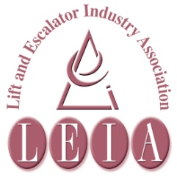
S

The Lift & Escalator Industry Association
SAFETY Matters
November 2014

Tel: 020 7935 3013
Fax: 020 7935 3321
Email: enquiries@leia.co.uk

Introduction
Welcome to the November 2014 edition of Safety Matters.
Through this newsletter our aim is to inform you of health and safety issues that may have an impact on the lift and escalator industry. Safety Matters is also available for download from the LEIA member’s website. www.leia.co.uk
Contents
- Electrical Safety
- Manual Handling Tops the List (Again)
- November Health Activities
- Asbestos Take 5 and Stay Alive

Manual Handling Tops the List (Again)
LEIA have published the Annual Accident Statistics for 2013, and once again, Manual Handling tops the list of causes of injury resulting in more than 7 days recovery from the injury. Of the 19 reported accidents, only 4 required less than 7 days recovery time before the injured person was fit enough to work again, and for that matter, probably fit enough to do any of the normal home activities they would be used to doing, like walking the dog, going to the gym or even sleeping.

HSE produce the MAC tool to help assess the risk of manual handling activities. Here’s an example from the section on carrying a load to your side:

http://www.hse.gov.uk/pubns/indg383.pdf

Electrical Safety
Individual companies will have their own procedures for controlling the risks from electricity.
This may include a procedure for isolating the supply, locking it off and checking to verify the equipment is dead (i.e. safe) before working on it.
Where the work cannot be undertaken with the power isolated – usually for the purpose of fault finding or taking measurements, it is essential your own company procedures are followed and if in any doubt consult your supervisor for advice.
Remember:
• Electricity can kill.
• Control voltages can kill.
• Wherever possible isolate, lock off and check equipment is dead before you work on it.
• Where live working is undertaken strictly follow your own company rules.

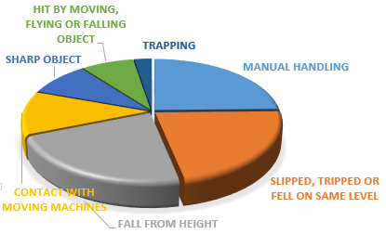

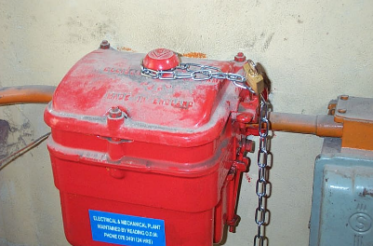

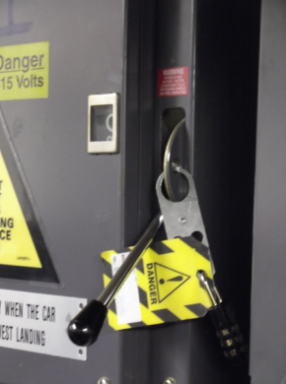
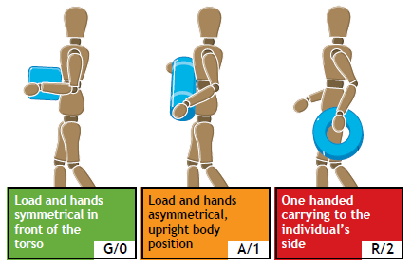

From National Stress Awareness Day, Alcohol Awareness Week, to International Men's Day, November is the perfect opportunity to organise health and wellbeing activities in your workplace
NOVEMBER HEALTH ACTIVITIES
Movember is a well-known fund-raising campaign for prostate cancer. How much of a ‘mo’ can you grow?
http://uk.movember.com/mens-health
Alcohol Concern is running Alcohol Awareness Week between 17th – 23rd November. The theme this year is ‘Taking back our health and high streets’
http://www.alcoholconcern.org.uk/what-we-do/campaigns/alcohol-awareness-week/
National Stress Awareness Day (NSAD) is on Wednesday Nov 5th 2014, organised by ISMA
http://www.isma.org.uk/about-national-stress-awareness-day-nsad/#.VFzA4_YqWUk
World COPD Day 2014 will be taking place on Wednesday 19 November 2014. Chronic obstructive pulmonary disease is the name used to describe several conditions including emphysema and chronic bronchitis. COPD is the UK's third biggest killer, taking 30,000 lives every year
http://www.blf.org.uk/page/world-copd-day
International Men's Day 19th November
http://www.internationalmensday.com/
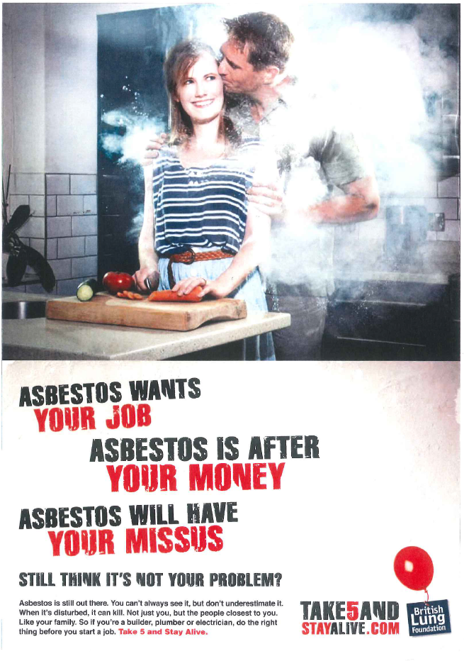
TAKE 5 AND STAY ALIVE
As well as the COPD campaign mentioned above, the British Lung Foundation have had a hard-hitting asbestos campaign running for some time, Called take 5 and Stay Alive, it lists 5 questions that you should be asking before you start work on any job:
- Do you suspect there’s asbestos on site?
- Can you be sure it’s asbestos?
- What’s the level of risk and how do you handle the risk safely?
- Have you had the right type of training?
- Are you taking precautions to minimise the risks?
http://www.take5andstayalive.com/

